RDS Task

- Create MariaDB DB on EC2.

Objective
To install and configure MariaDB Server on an AWS EC2 instance, create a database and verify that it is working correctly.

Prerequisites
- EC2 instance running
- SSH/EC2 Instance Connect access
- Amazon Linux 2023 recommended
- sudo privileges

Step 1: Connect to EC2
- AWS Console → EC2 → Instances → Select your instance → Connect
- Use EC2 Instance Connect or SSH.

Update Packages
- For Amazon Linux 2023

Updated Packages
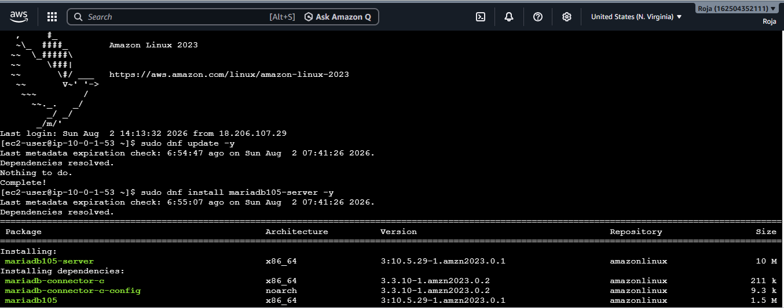

Install MariaDB:
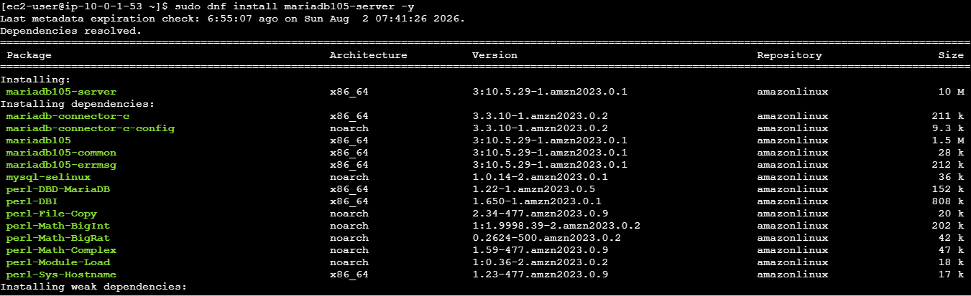
Start, enable, check status of Mariadb
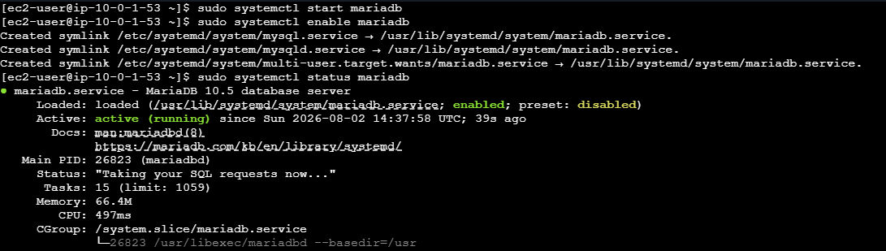

Secure MariaDB using sudo mysql_secure_installation

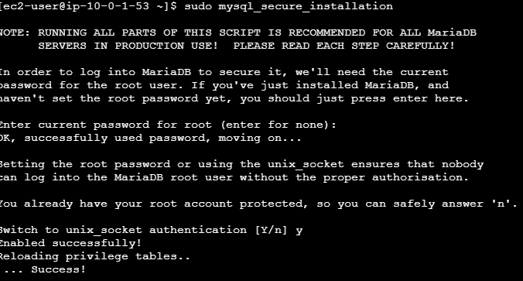

As this is a fresh MariaDB installation, press Enter and set the password

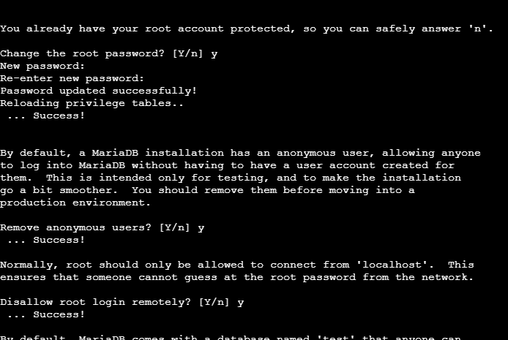

Login to MariaDB, Create a Database and verify Database and then exit.

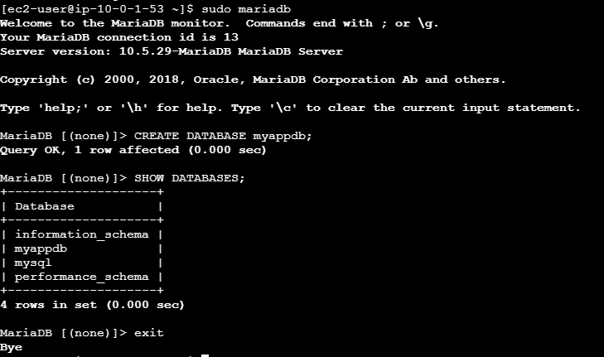

- Insert some dummy data.

Objective
To create a sample table in the MariaDB database and insert dummy records for testing.

Prerequisite
You should already have created the database:
myappdb

1. Login to MariaDB and Select the Database create a table and verify the table
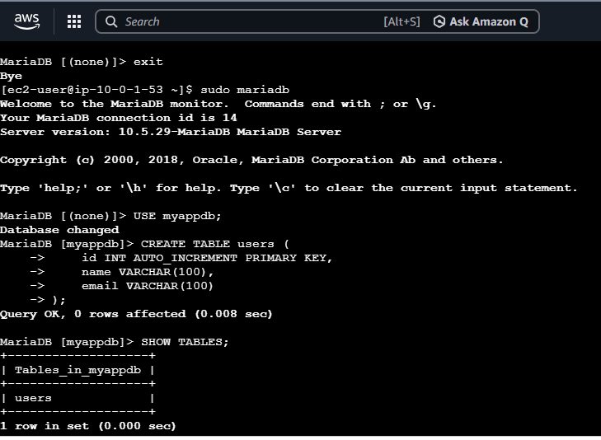

2. Insert dummy data into the table and verify the data:

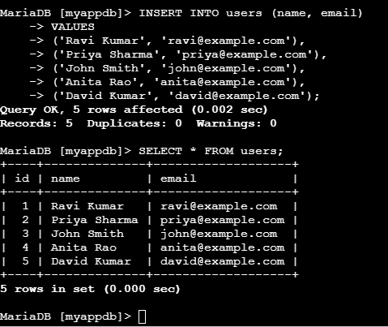

- Take the backup of dummy data on EC2.

Objective
To take a backup of the MariaDB database containing dummy data and store the backup file on the EC2 instance.
We will use mysqldump to create the backup.
1. Create a Backup Directory and Take Backup of the Database. Verfify Backup file
Check Backup Contents:
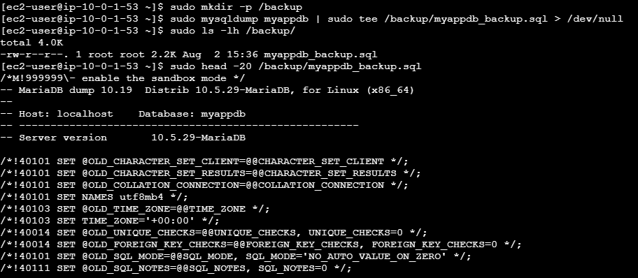

2.Verified back up to check if it contains dummy data:

- Launch MariaDB RDS instance.

Objective
To create an Amazon RDS MariaDB database inside a custom VPC and configure secure connectivity from an EC2 application server.

Requirements
- AWS Account
- Custom VPC
- At least two subnets in different Availability Zones
- EC2 instance for application/database testing
- Security Group
- Amazon RDS

Step 1: Create an RDS DB Subnet Group
AWS Console → RDS → Subnet groups
Click: Create DB subnet group
Enter:
Name: mariadb-subnet-group
Description: Name: mariadb-subnet-group
subnet group for MariaDB
VPC: Your custom VPC

Under Add subnets: Availability Zone: us-east-1a
Subnet: Private-Subnet-1

Availability Zone: us-east-1b
Subnet: Private-Subnet-2
Click: Create

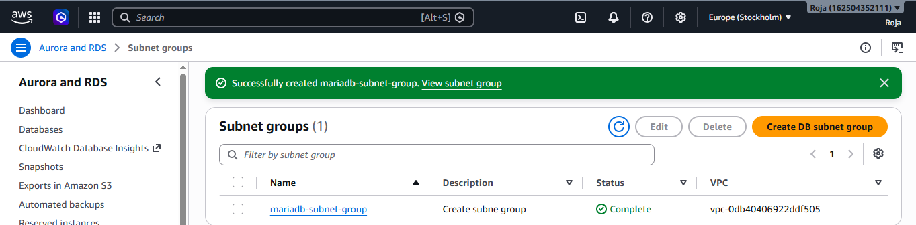
Step 2: Create Security Group for RDS
EC2 → Security Groups → Create security group
Enter:
Security group name: MariaDB-RDS-SG
Description: Security group for MariaDB RDS
VPC: Your custom VPC

Inbound rule
MYSQL/Aurora | 3306 | Your EC2/Application security group
Outbound rule

All traffic 0.0.0.0/0

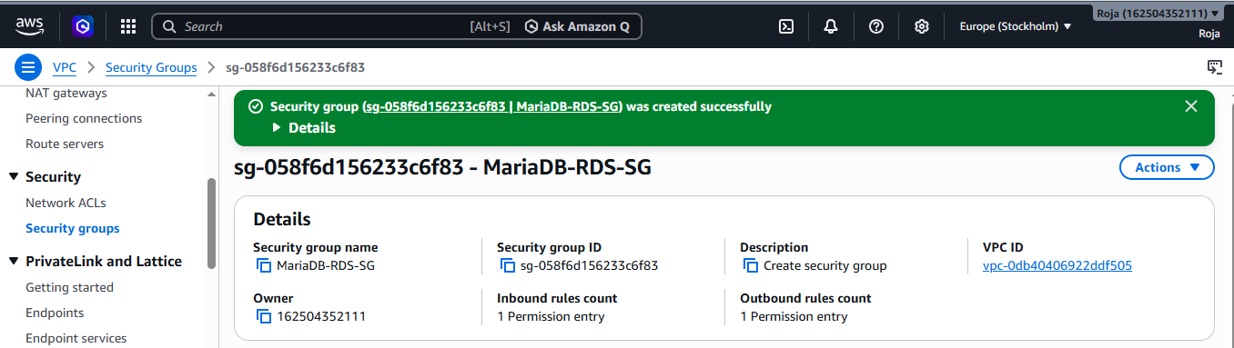

Step 3: Create Database
RDS → Databases → Create database
Select:
Database creation method:
Standard create
Database in moving to VPC state:
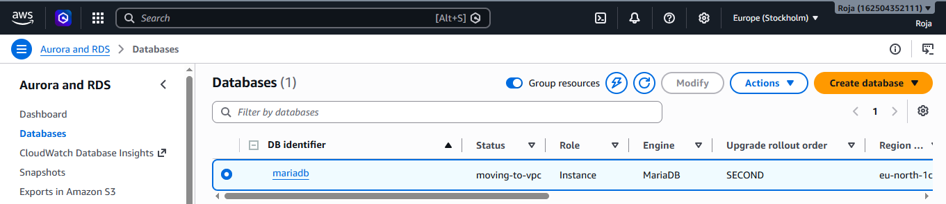
Datebase in Available state:
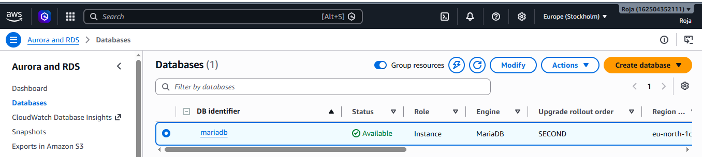

Step 4: Get RDS Endpoint
Connectivity & security
Find:
Endpoint
Port: 3306
The endpoint will look similar to:
mariadb.c7ekw64csm4s.eu-north-1.rds.amazonaws.com
Copy the endpoint.
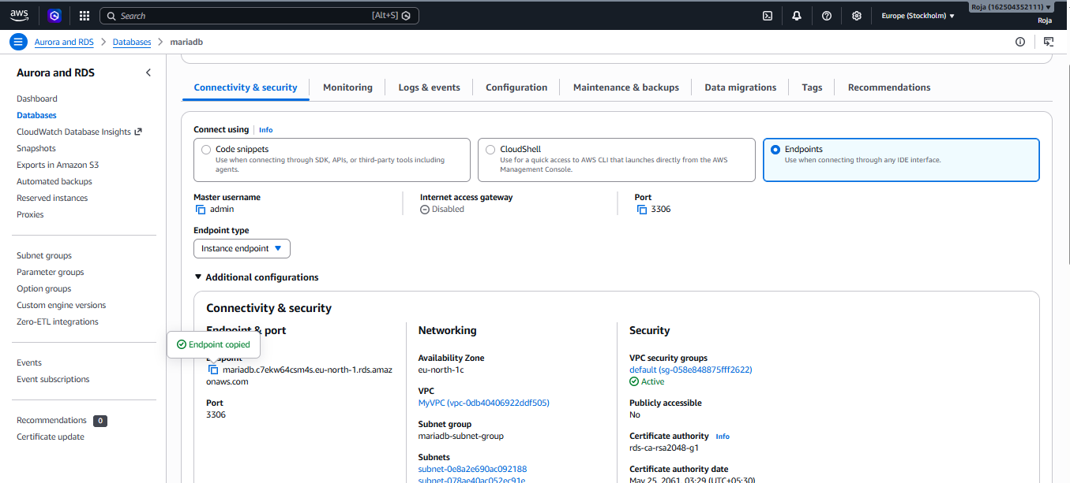

Step 5: Test Connection From EC2
If you have an EC2 instance that is allowed to connect to the RDS security group, use the MariaDB client from that EC2.
mariadb -h <RDS-ENDPOINT> -P 3306 -u admin -p
Then enter your RDS master password.
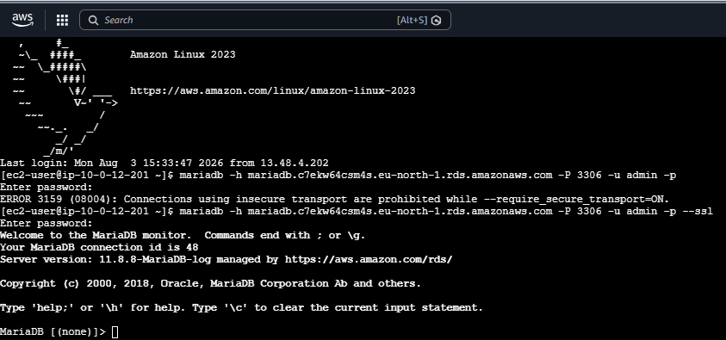

- Migrate database from EC2 to RDS.

Objective
To migrate the MariaDB database and its dummy data from a MariaDB database running on EC2 to a MariaDB RDS instance.

Prerequisites
- MariaDB is installed and running on EC2.
- Dummy database/data exists on EC2.
- MariaDB RDS instance is created.
- RDS status is Available.
- RDS has Public access = No if following the training setup.
- EC2 can connect to RDS on TCP port 3306.
- You know the RDS endpoint.
- You know the RDS master username and password.
Step 1: Connect to the EC2 Instance and Check MariaDB
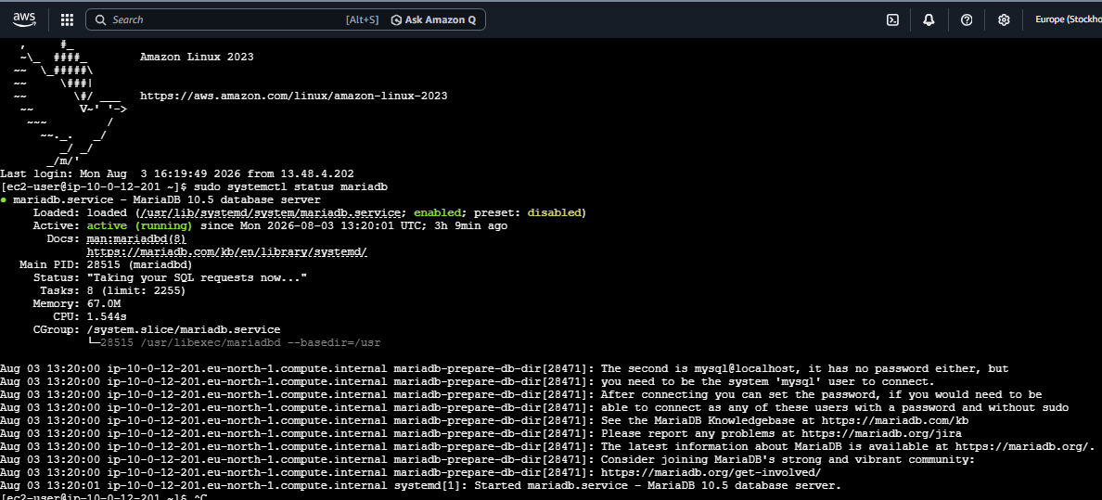
Step 2: Check the Database on EC2
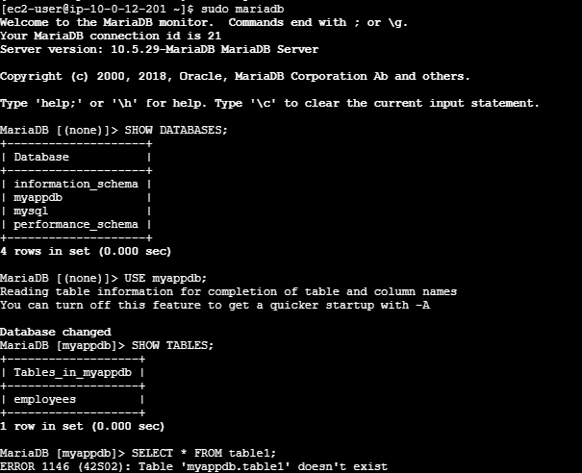
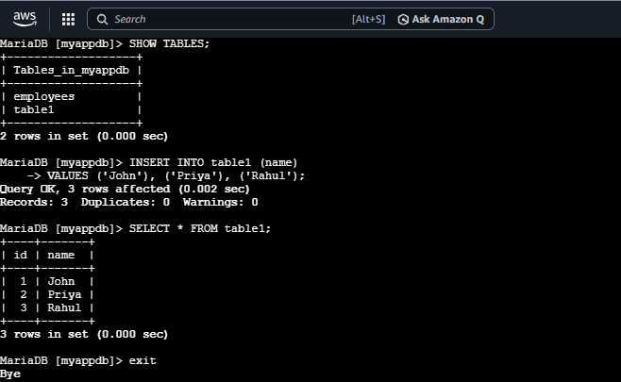

Step 3: Take the Database Backup and verify the backup file
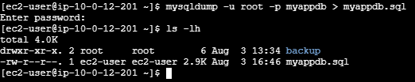

Step 4: Get the RDS Endpoint
AWS Console → RDS → Databases → Your MariaDB RDS
Open:
Connectivity & security
Copy the Endpoint.
It will look similar to:
mariadb-rds.xxxxxxxxxxxx.us-east-1.rds.amazonaws.com
Also confirm:
Port: 3306
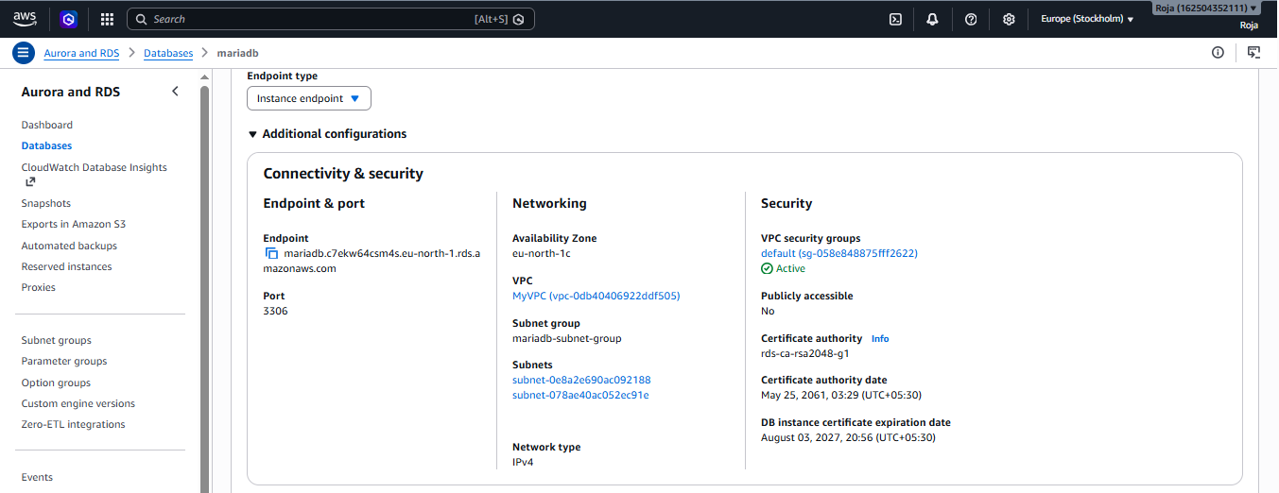

Step 5: Create a Database in RDS
Connect to RDS & Enter the RDS master password.
mariadb -h <RDS-ENDPOINT> -P 3306 -u admin –p
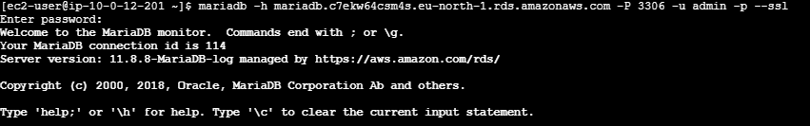

Step 6: Verify RDS Connection & Create the Destination Database
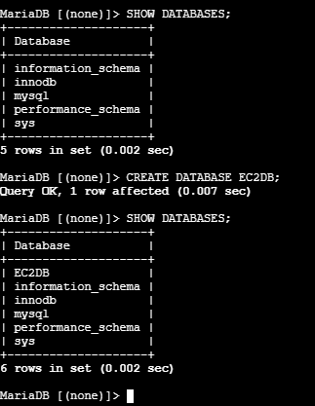

Step 7: Import the Backup into RDS

Step 8: Verify the Migration
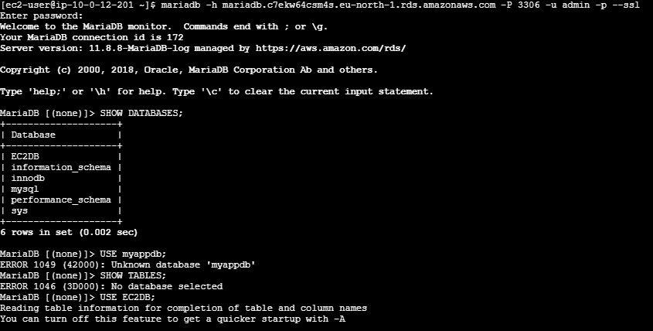
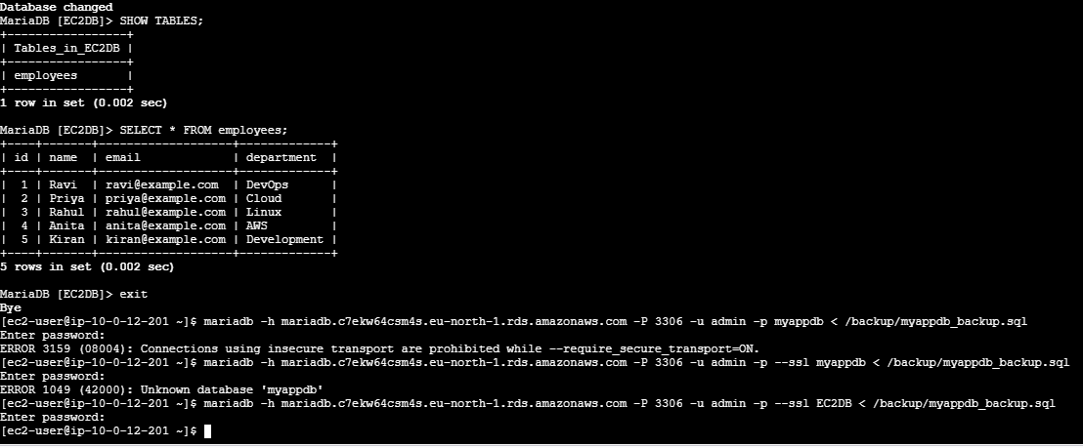

- Install MySQL DB on EC2.
Step 1: Connect to the EC2 instance & Update the system
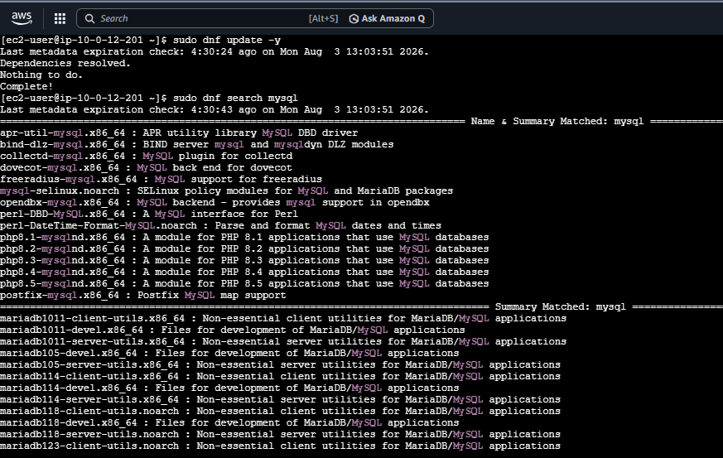

Step 2: Start the database service & Enable the service at boot
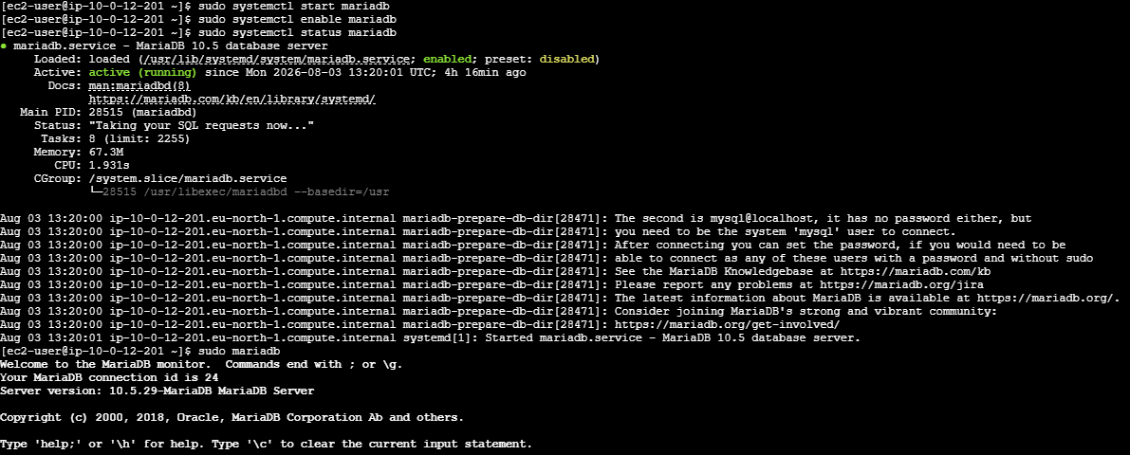

Step 3: Login to the database & Verify the database
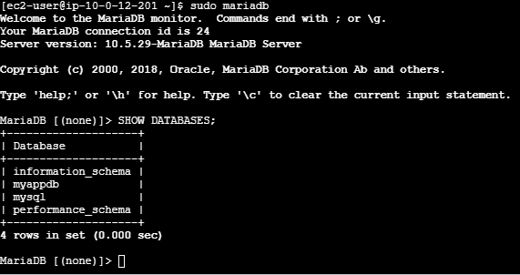

- Launch MySQL RDS image.

Step 1: Choose Database Creation Method
Under Database creation method
Database in creating state:
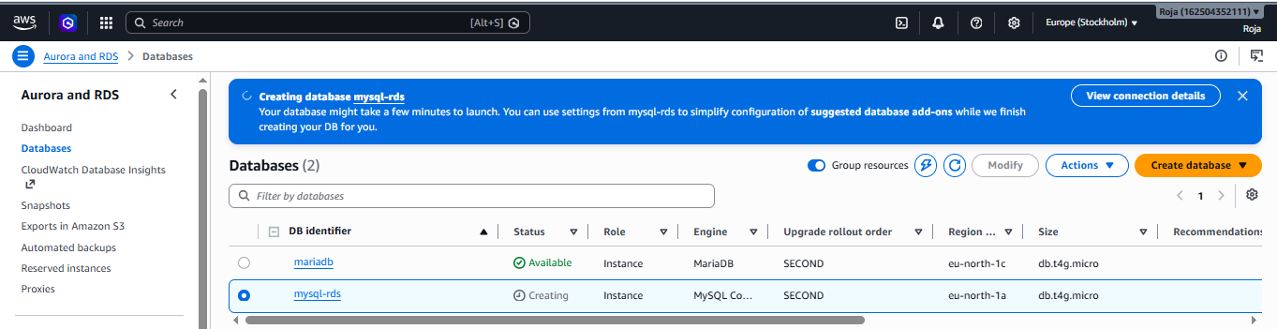
Database in Available state:
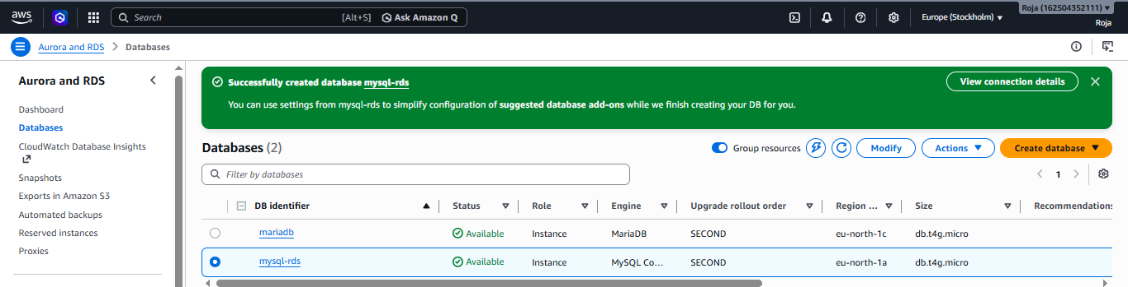

- Configure Multi-AZ.

Step 1: Open Amazon RDS
- Log in to the AWS Management Console.
- Select your required AWS Region.
- Search for RDS.
- Open Amazon RDS.
- Select Databases from the left menu.

Step 2: Select Your Database
- Click the RDS database for which you want to enable Multi-AZ.
- Click Modify.

Step 3: Find Availability Settings
In the Modify DB instance page, find the Availability & durability section.
Look for:
Multi-AZ deployment

Step 4: Enable Multi-AZ
Select:
Create a standby instance or the equivalent Multi-AZ option shown by your RDS engine/configuration.
This creates a standby database in a different Availability Zone.
“Create a standby instance” is not highlighted/clickable while creating my MariaDB RDS, the most common reason is that current database settings doesn't support the Multi-AZ option I'm trying to select.

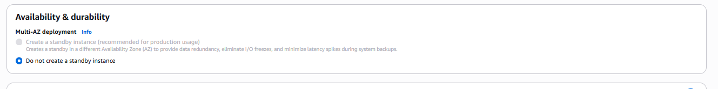

- Take backup of DB and restore the DB.

Step 1: Check the database
Login to MariaDB, Check databases, Select your database, Check tables, Check your dummy data:
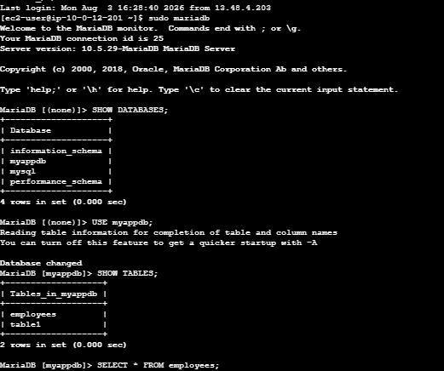
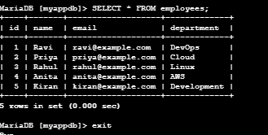

Step 2: Create a backup directory, Take the database backup & Step 4: Verify the backup
Check that the backup contains data:

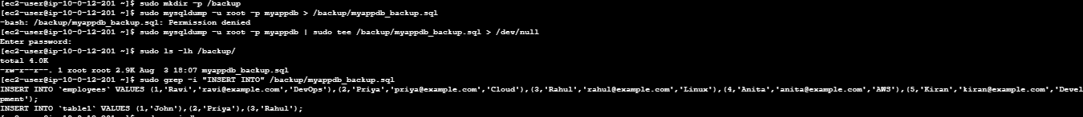

Step 3: Create the restore database, Restore the backup, Verify the restored database
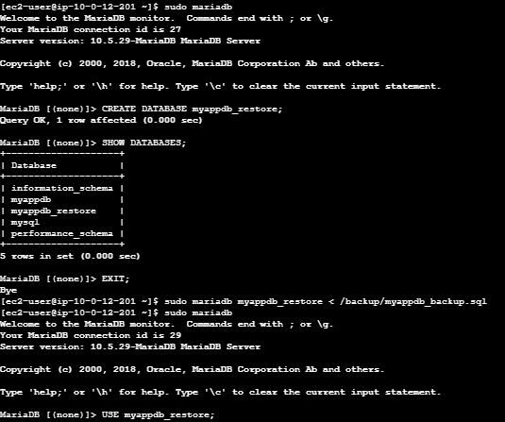
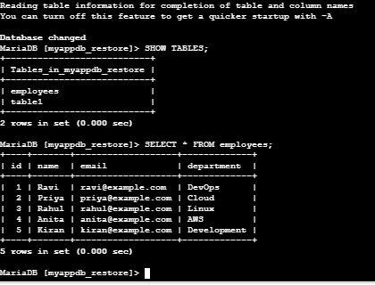

- Create read replica.

Step 1: Select the Source Database
- Click your existing MySQL/MariaDB RDS database.
- Make sure its status is:
Available

Step 2: Create Read Replica
- Click Actions.
- Select Create read replica.

Step 3: Configure the Read Replica
Under the read replica settings, provide:
DB instance identifier:
mariadb-read-replica
You can choose any meaningful name.

Step 4: Configure Storage
Configure the storage according to your lab requirements.
For a basic assignment, you can generally keep the existing/default storage configuration.

Step 5: Configure Connectivity
Select:
- VPC: Your existing VPC
- DB subnet group: Appropriate DB subnet group
- Public access: No
- Security group: Your RDS security group
Your replica should remain private:
Application EC2
|
| Read traffic
↓
Read Replica

Step 8: Configure Availability Zone
You can select a different Availability Zone from the source database if required.
For example:
Source RDS
AZ-A
|
| Replication
↓
Read Replica
AZ-B

Step 9: Create the Read Replica
Review the configuration.
Click:
Create read replica
AWS will begin creating the replica.
The status may initially show:
Creating
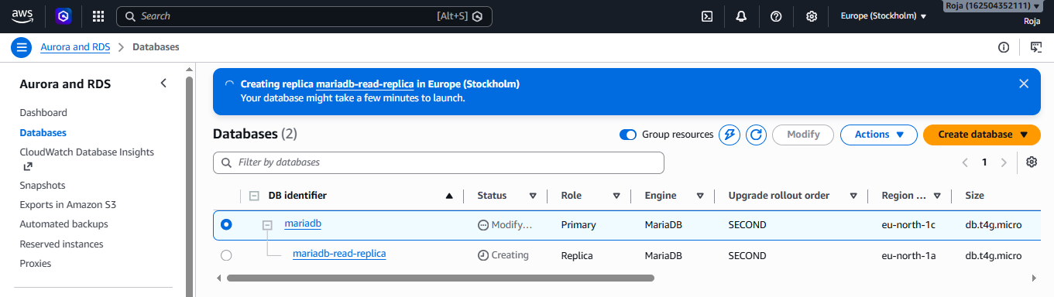
Wait until the status becomes:
Available

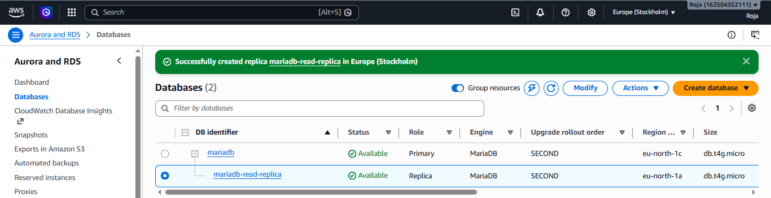

Step 10: Verify the Read Replica
Go to:
RDS → Databases
You should now see two databases:
mariadb-rds
mariadb-read-replica
Click the read replica and check its details.
You should be able to identify that it is associated with the source DB instance.
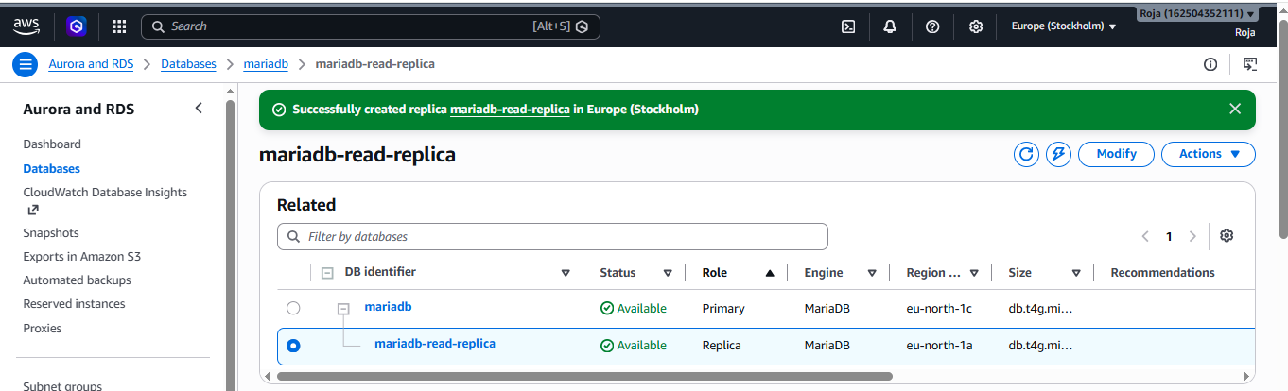

Step 11: Verify the Data
Connect to the read replica using its endpoint:
mariadb -h <READ-REPLICA-ENDPOINT> -P 3306 -u admin -p
Then:
SHOW DATABASES;
Select your database:
USE myappdb;
Check the tables:
SHOW TABLES;
Check the data:
SELECT * FROM employees;
The replica should contain the data replicated from the source RDS database.
